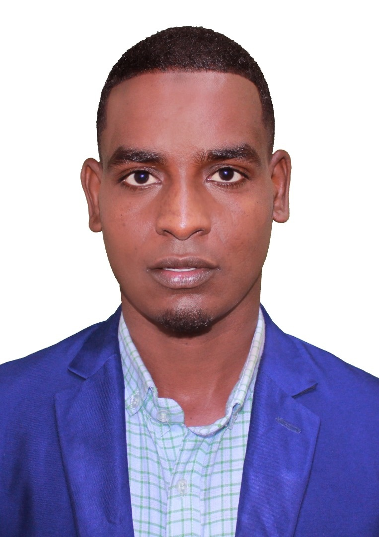 | Abdirahman Osman Ali  Full-Stack Web Developer

📧 Email : abdirahmanosmanali28@gmail.com
📞 Phone : +252 615 269 156
💻 GitHub : github.com/maankajr/Maank
Profile Summary
I'm a full-stack developer skilled in frontend technologies like React, Bootstrap, and Tailwind CSS, and backend tools like Node.js, Express, MySQL, and MongoDB. I focus on creating responsive, dynamic, and data-driven web applications.
About
I am a Full-Stack Web Developer and a fourth-year Computer Science student at Somali National University, with a strong interest in modern web development and software engineering. I graduated from Deero Institute in Full-Stack Web Development in 2025 and continue to develop my skills in building responsive, scalable, and user-focused web applications using modern technologies.
Experience
Teaching at Al-Bayaan School
- Helped students improve academically by preparing tests, tracking progress, and offering personalized feedback.
Development Experience
- Built real-world applications like Ogmaal.com (an e-learning platform) and a Hospital Management System using the MERN stack.
Skills
Frontend: HTML, CSS, JavaScript, React, Bootstrap, Tailwind CSS
Backend: Node.js, Express
Databases: MySQL, MongoDB
Soft Skills: Teaching, communication, teamwork
Projects
Ogmaal.com – E-learning platform
Role: Full-stack development • Stack: React, Node.js, MongoDB
Hospital Management System
Role: Backend/database integration • Stack: Node.js, Express, MySQL/MongoDB
Age Calculator App
Role: Frontend development • Stack: HTML, CSS, JavaScript
Services
- Full-stack Web Development
- Frontend UI Design (React, Tailwind, Bootstrap)
- Backend API Development (Node.js, Express)
- Tutoring in programming/web development
Contact
📧 Email : abdirahmanosmanali28@gmail.com
📞 Phone : +252 615 269 156

